Integration Testing:
After completion of dependent programs development & Unit Testing, the programmers interconnect them. The programmers can check the interconnection of the programs in any one of the below four ways,
- Top-Down Approach
- Bottom-up Approach
- Hybrid Approach
- System Approach
Top-Down Approach:
The interconnection between the main program & some sub programs is called Top-Down Approach. Programmers used temporary program called Stubs instead of subprograms, which are under construction. The other name of stub is “Called programs”. A stub returns control to the main program.

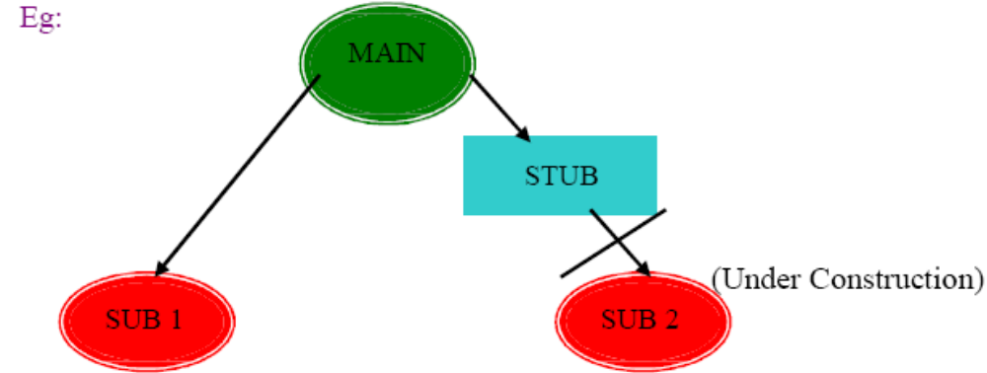
- In this approach first parent modules are developed
- After that child modules are developed
- Then interconnect to parent& child modules
- In the interconnection process is their any sub-modules is under construction then the developer create temporary program instead of sub modules that is called “Stub”
2. Bottom-up Approach;
The interconnection of internal sub-programs without using main program is called the bottom-up approach. In this approach programmers use temporary program instead of main program, which is under construction? The temporary program is called “Driver” /”Calling Program”.
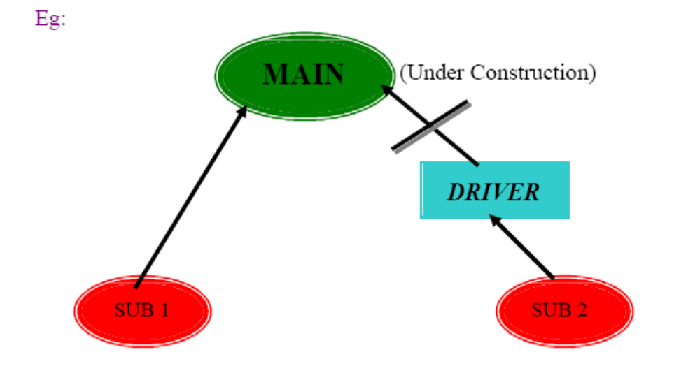
- In this approach first child modules are developed
- After the parent modules are developed
- Then incorrect child modules with parent modules
- In interconnection process is their any main module is under construction then the developers create temporary program that is called “Driver’’
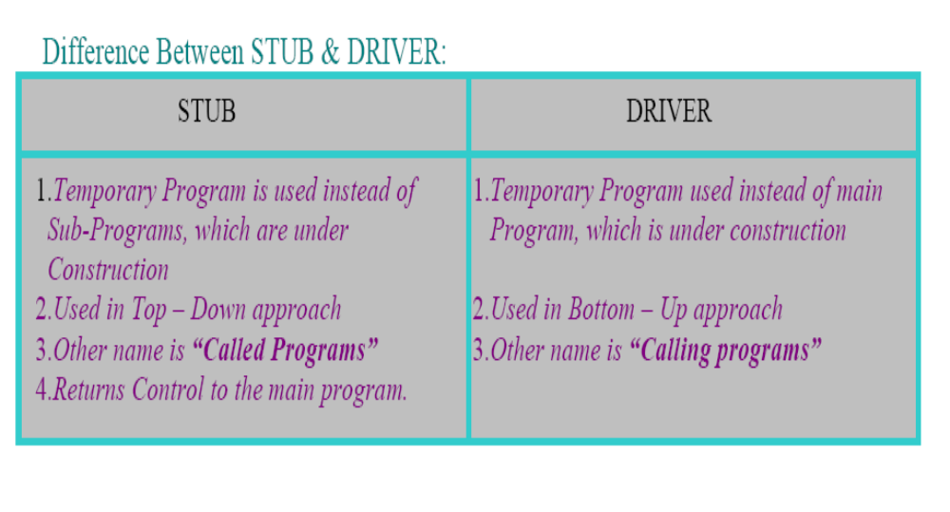
3. Hybrid Approach:
Also known as a “sandwich approach”, this is combination of process Top-Down Approach & Bottom-Up Approaches.

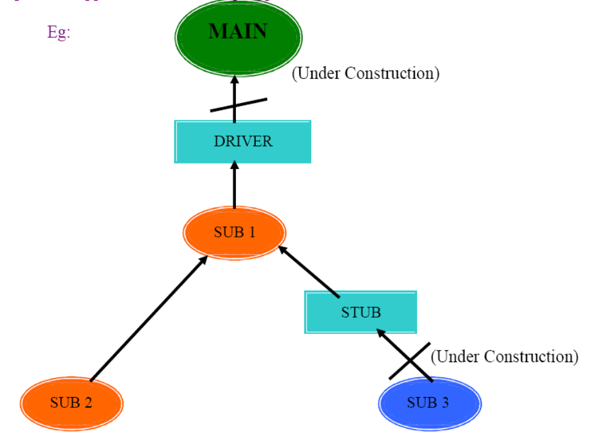
4. System Approach:
It is also known as “Big-Bang Approach”. From this approach programmers interconnect those modules Unit testing & Integration testing.

Here developer integrates all modules in one time. And verifies systems working as expected or not.

Note:→ once system approach successful developer release
Software to conduct system testing

